AI Use Declaration Form
Course: Introduction to Artificial Intelligence
Lab Title: Lab 4
Student Name: ______Jeffrey otoo_____________________________________________
Student ID: ____________14302028__________________________________________
GitHub Repository Link: ______https://github.com/cblanco11/lab-4-llm-decision-support_____________________________________
Date Submitted: ___________16/08/26_______________________________________

1. AI Use Summary
Question | Student Response
Did you use any AI tool for this lab? | Yes
Estimated percentage of the work influenced by AI | %20
Did you attach evidence of AI use where applicable? | Yes

2. Details of AI Use
Complete the table below for each AI tool used. Add more rows where necessary.
Name of AI Tool Used | Purpose for Using the Tool | Prompt or Instruction Given to the Tool | Part(s) of the Work Influenced by the Tool | How I Verified, Edited, or Improved the AI Output
Claude | Error when running a code | Im getting an error | Part 4.2 | Edited a previous code block(section 3.2) without running, so the error came as a result of that
Claude | Asked it to compare my code with the output | Compare my code with the output it gave | Part 3.1 | Compared it’s answer with the answer when I run the code

3. Attachment of AI Output Evidence
Where required, attach evidence of AI use. Tick all that apply. Add more rows where necessary.
Evidence Type | Attached? (Yes, No, N/A) | File Name
AI-generated draft
Prompt history | 1.  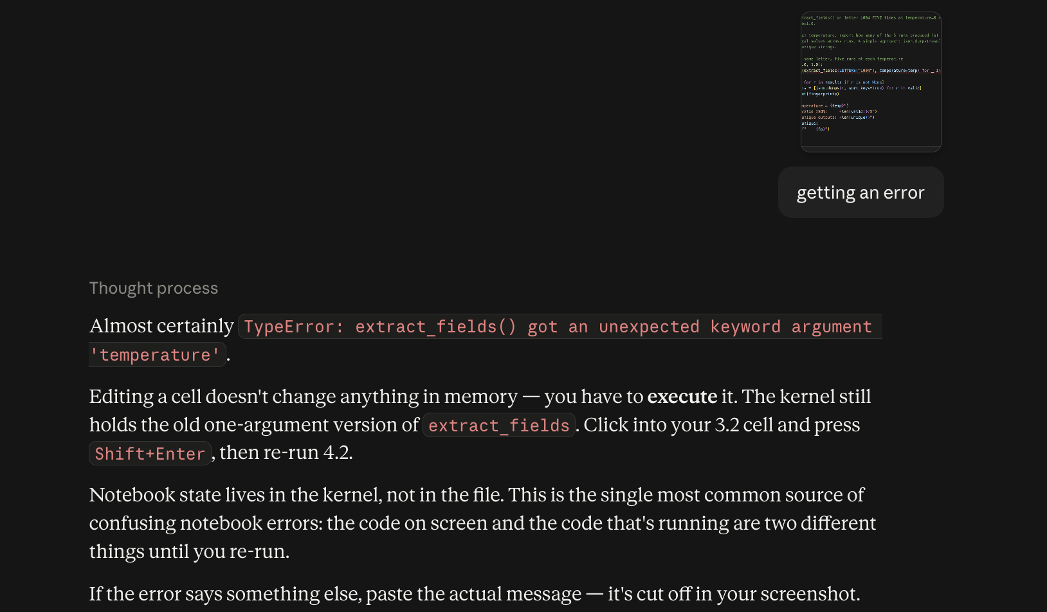  2.  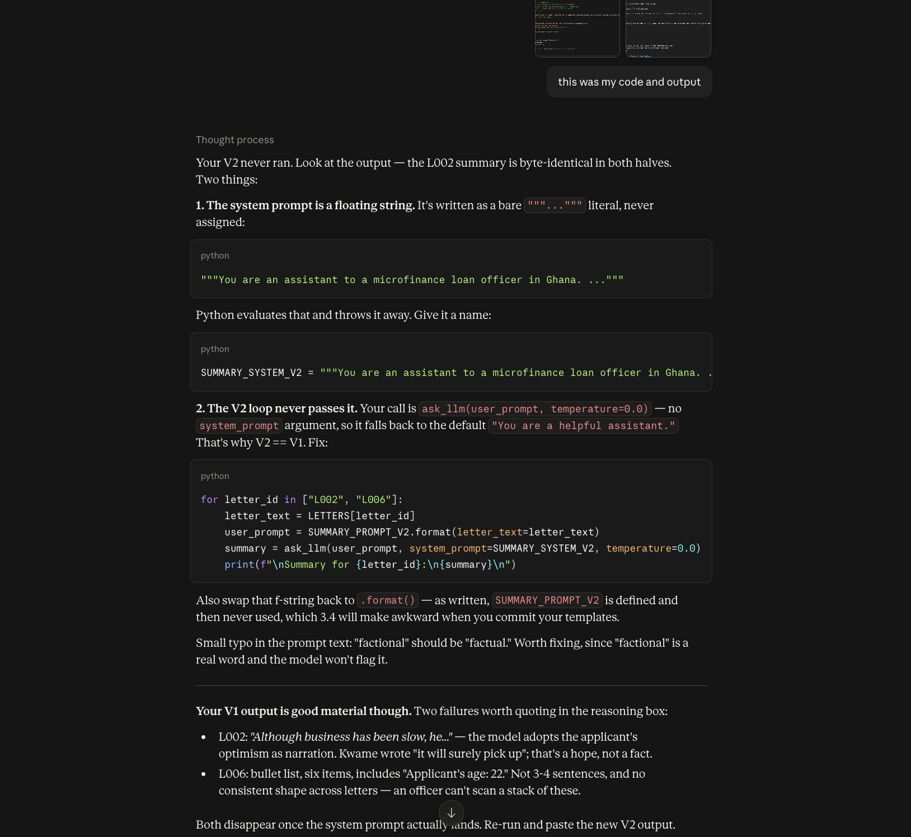
Screenshot of AI interaction
Exported AI conversation
AI-generated code snippet
Revised version showing student input

4. Student Declaration
I declare that:
Declaration Statement | Response (Yes/No)
The submitted work is my own work. | Yes
Any use of AI tools has been clearly declared in this form. | Yes
The prompts, instructions, and AI-generated outputs have been disclosed where applicable. | Yes
I reviewed, tested, edited, and improved any AI-generated content before submission. | Yes
My AI usage does not exceed 25% of the entire work. | Yes
I understand that undeclared or excessive AI use may be treated as academic misconduct. | Yes

Student Signature: ____________________Jeffrey Otoo_______________________
Date: ________________________16/08/26___________________

